Computer Programming Lab

Lab Evaluation 2

**Questions:**

1. Write a C program to create 2 3x3 matrices whose value will be passed by user. [1 Marks]

#include <stdio.h>

int main()

{

int i, j, m[3][3];

printf("\nEnter the elements in the first matrix :\n");

for(i=0; i<3; i++){

for(j=0; j<3; j++)

scanf("%d", &m[i][j]);

}

printf("\nThe matrix :\n");

for(i=0; i<3; i++){

for(j=0; j<3; j++)

printf("%d\t", m[i][j]);

printf("\n");

}

return 0;

}

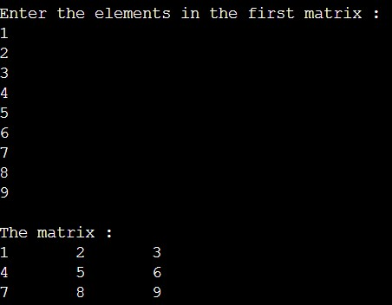

2. Write function for the following (for first matrix): [3 * 3 Marks = 9 Marks]

a. To print lower triangular matrix as shown.

If matrix = 1 2 3

4 5 6

7 8 9

Output = 1

4 5

7 8 9

#include <stdio.h>

int main()

{

int i, j, m[3][3];

printf("\nEnter the elements in the first matrix :\n");

for(i=0; i<3; i++){

for(j=0; j<3; j++)

scanf("%d", &m[i][j]);

}

printf("\nThe matrix :\n");

for(i=0; i<3; i++){

for(j=0; j<3; j++)

printf("%d\t", m[i][j]);

printf("\n");

}

printf("\nThe lower triangular matrix :\n");

for(i=0; i<3; i++){

for(j=0; j<=i; j++)

printf("%d\t", m[i][j]);

printf("\n");

}

return 0;

}

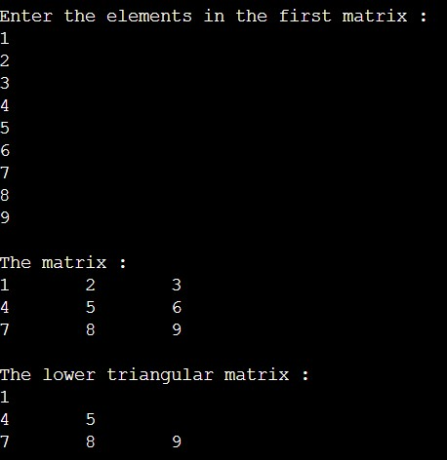

1. b. Interchange the row as per below exchanges:

Row 1 -> Row 3

Row 2 -> Row 1

Row 3 -> Row 2

#include <stdio.h>

int main()

{

int i, j, m[3][3];

printf("\nEnter the elements in the first matrix :\n");

for(i=0; i<3; i++){

for(j=0; j<3; j++)

scanf("%d", &m[i][j]);

}

printf("\nThe matrix :\n");

for(i=0; i<3; i++){

for(j=0; j<3; j++)

printf("%d\t", m[i][j]);

printf("\n");

}

int temp, intermediate;

for (i=0; i<3; i++) {

temp = m[0][i] ;

m[0][i] = m[2][i];

intermediate = m[1][i];

m[1][i] = temp;

m[2][i] = intermediate;

}

printf("\nThe matrix after the rows are interchanged :\n");

for(i=0; i<3; i++){

for(j=0; j<3; j++)

printf("%d\t", m[i][j]);

printf("\n");

}

return 0;

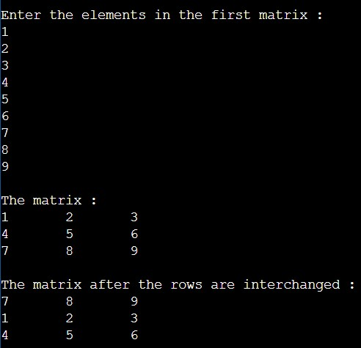}

1. c. Arrange each column elements in descending order.

#include <stdio.h>

int main()

{

int i, j, k, m[3][3];

printf("\nEnter the elements in the first matrix :\n");

for(i=0; i<3; i++){

for(j=0; j<3; j++)

scanf("%d", &m[i][j]);

}

printf("\nThe matrix :\n");

for(i=0; i<3; i++){

for(j=0; j<3; j++)

printf("%d\t", m[i][j]);

printf("\n");

}

for (int k = 0; k < 3; k++) {

for (int i = 0; i < 2; i++) {

for (int j = i + 1; j < 3; j++) {

if (m[j][k] > m[i][k]) {

int temp = m[j][k];

m[j][k] = m[i][k];

m[i][k] = temp;

}

}

}

}

printf("\nThe matrix after the columns are arranged in descending order :\n");

for(i=0; i<3; i++){

for(j=0; j<3; j++)

printf("%d\t", m[i][j]);

printf("\n");

}

return 0;

}

* 1. 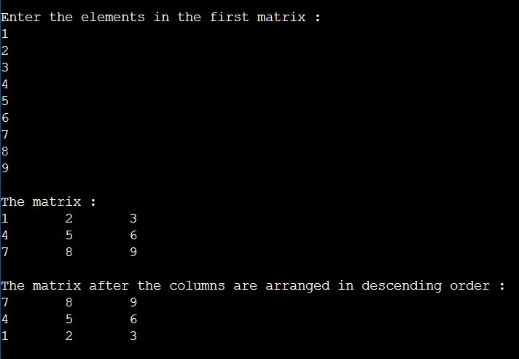
  2. 3. Write the following function: [2 * 5 Marks = 10 Marks]
  3. a. Addition/Subtraction of matrices where operation is selected by user.

#include <stdio.h>

void sum(int r1, int c1, int r2, int c2, int arr1[r1][c1], int arr2[r2][c2]){

int i,j;

printf("\nThe sum of the matrices :\n");

for(i=0; i<r1; i++){

for(j=0; j<c1; j++)

printf("%d\t", arr1[i][j]+arr2[i][j]);

printf("\n");

}

}

void sub(int r1, int c1, int r2, int c2, int arr1[r1][c1], int arr2[r2][c2]){

int i,j;

printf("\nThe subraction of the matrices :\n");

for(i=0; i<r1; i++){

for(j=0; j<c1; j++)

printf("%d\t", arr1[i][j]-arr2[i][j]);

printf("\n");

}

}

int main()

{

int r1, c1, r2, c2, i, j;

char op, buffer;

printf("Enter the number of rows in the first matrix: ");

scanf("%d", &r1);

printf("Enter the number of columns in the first matrix: ");

scanf("%d", &c1);

int m1[r1][c1];

printf("\nEnter the elements in the first matrix :\n");

for(i=0; i<r1; i++){

for(j=0; j<c1; j++)

scanf("%d", &m1[i][j]);

}

printf("\nEnter the number of rows in the second matrix: ");

scanf("%d", &r2);

printf("Enter the number of columns in the second matrix: ");

scanf("%d", &c2);

scanf("%c", &buffer);

printf("\nEnter the operator (+,-): ");

scanf("%c", &op);

if ( (r1 == r2) && (c1 == c2) ){

int m2[r2][c2];

printf("\nEnter the elements in the second matrix :\n");

for(i=0; i<r2; i++){

for(j=0; j<c2; j++)

scanf("%d", &m2[i][j]);

}

printf("\nThe first matrix :\n");

for(i=0; i<r1; i++){

for(j=0; j<c1; j++)

printf("%d\t", m1[i][j]);

printf("\n");

}

printf("\nThe second matrix :\n");

for(i=0; i<r2; i++){

for(j=0; j<c2; j++)

printf("%d\t", m2[i][j]);

printf("\n");

}

if(op == '+')

sum(r1,c1,r2,c2,m1,m2);

else

sub(r1,c1,r2,c2,m1,m2);

}

else

printf ("Matrices with entered orders can't be added with each other.");

return 0;

}

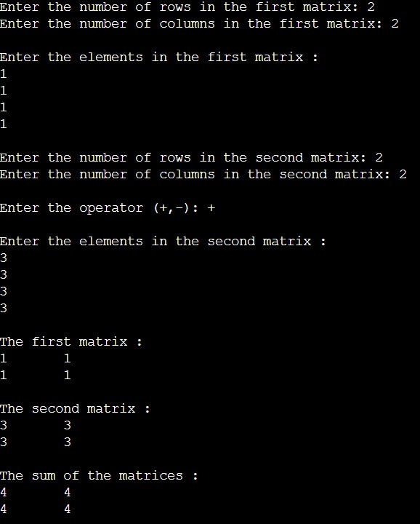

* 1. b. Multiplication of matrices.

#include<stdio.h>

int main()

{

int r1, c1, r2, c2, i, j, k, sum=0;

printf("Enter the number of rows in the first matrix: ");

scanf("%d", &r1);

printf("Enter the number of columns in the first matrix: ");

scanf("%d", &c1);

int m1[r1][c1];

printf("\nEnter the elements in the first matrix :\n");

for(i=0; i<r1; i++){

for(j=0; j<c1; j++)

scanf("%d", &m1[i][j]);

}

printf("\nEnter the number of rows in the second matrix: ");

scanf("%d", &r2);

printf("Enter the number of columns in the second matrix: ");

scanf("%d", &c2);

int m2[r2][c2];

int multiplication[r1][c2];

(c1 != r2)?

(printf("Matrices with entered orders can't be multiplied with each other.\n")):

(

{

printf("\nEnter the elements in the second matrix :\n");

for(i=0; i<r2; i++){

for(j=0; j<c2; j++)

scanf("%d", &m2[i][j]);

}

printf("\nThe first matrix :\n");

for(i=0; i<r1; i++){

for(j=0; j<c1; j++)

printf("%d\t", m1[i][j]);

printf("\n");

}

printf("\nThe second matrix :\n");

for(i=0; i<r2; i++){

for(j=0; j<c2; j++)

printf("%d\t", m2[i][j]);

printf("\n");

}

for(i=0; i<r2; i++){

for(j=0; j<c1; j++){

for(k=0; k<c2; k++){

sum = sum + m1[i][k]*m2[k][j];

}

multiplication[i][j] = sum;

sum = 0;

}

}

printf("\nThe multiplication of the two matrices :\n");

for ( i = 0 ; i < r1 ; i++ ){

for ( j = 0 ; j < c2 ; j++ )

printf("%d\t", multiplication[i][j]);

printf("\n");

}

}

);

return 0;

}

